**Fundamentals of Data warehousing**

**1. What is the need for BI?**

**BI is the of transforming raw/operational data into useful information for business analysis**

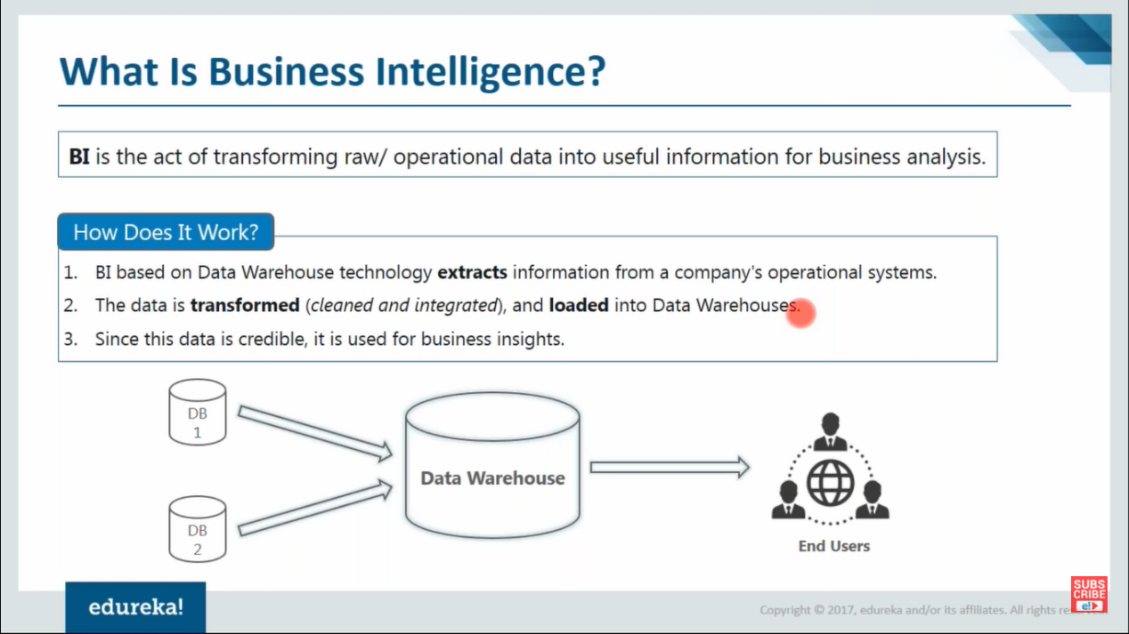

Need…

It is the activity which contributes to growth of any company.

-----Planning of what need to be done(expecting output)-> Gathering data -> Data analysis -> Business action----

Without data warehousing data visualization cant be done as data cant be taken directly from data source

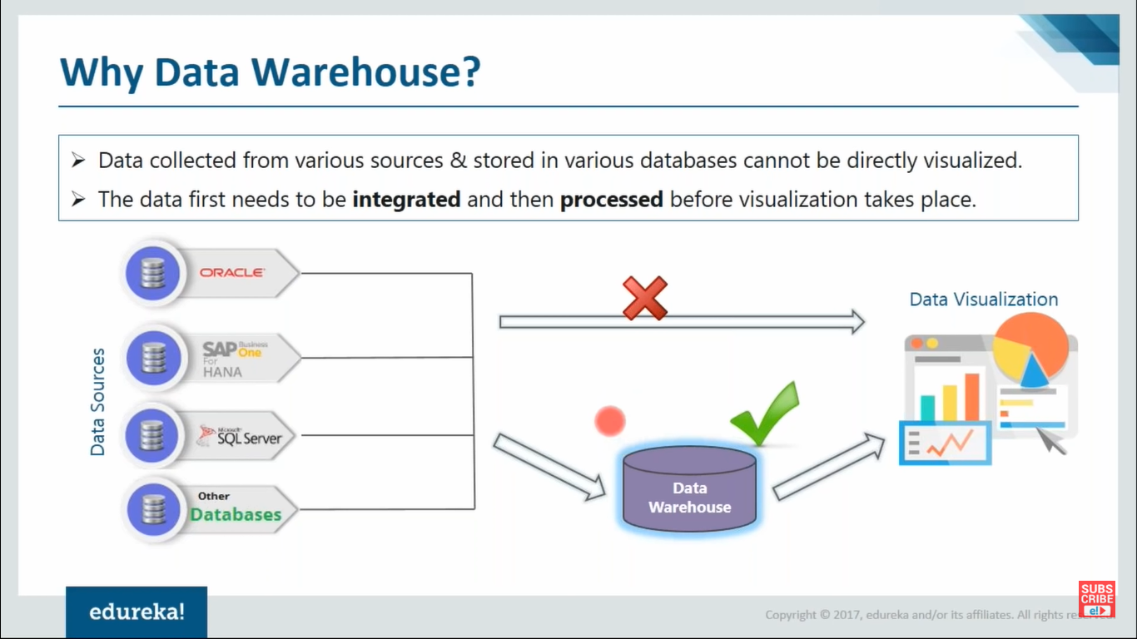

**Why Data warehouse?**

When data is present in different dbs should be integrated first before visualization

**What is data warehousing?**

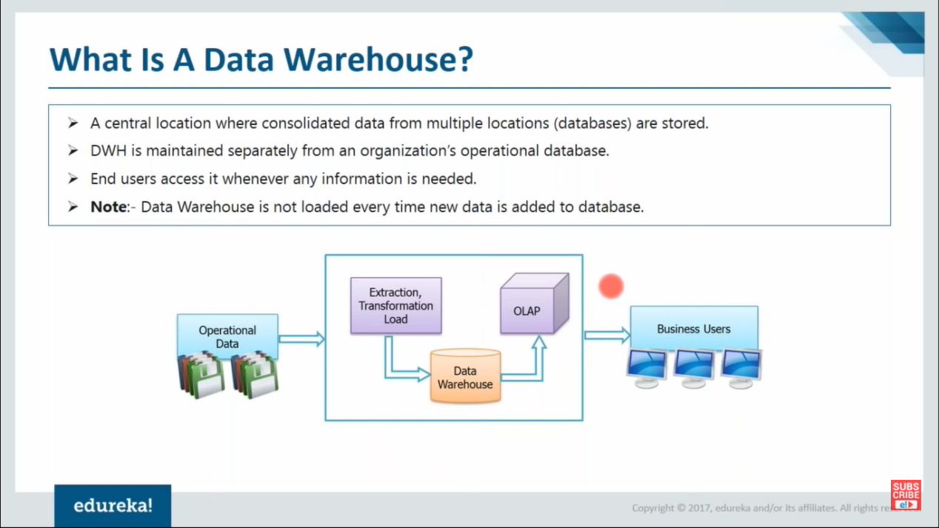

Dwh is maintained separately from organizations operational data so that the original data don’t get corrupted.

-> The process of getting data from operational database to data warehouse is called ETL.

->OLAP - is used to refer to business analysis

**Advantages of Data warehouses**

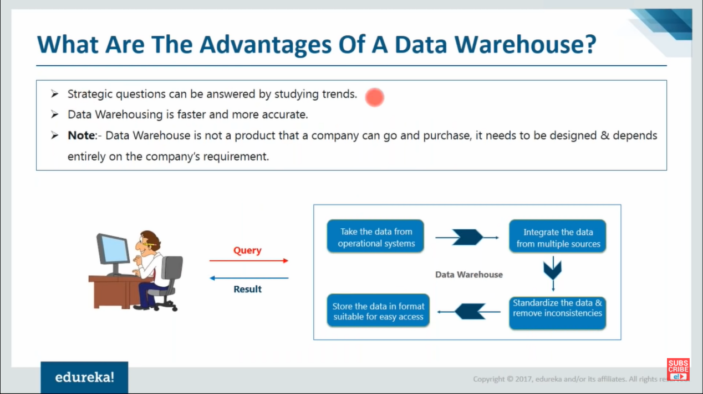

**Note:**Data warehouses has legacy data(historical) whereas operational db has the real time data that may not to be updated to DW.

**\*** there can be multiple DBs in an organization(not related directly) but the imported data from different dbs can then be related in DW (different datas of dbs can be linked in DW)

**Note:** Processed data is called information (which can give some meaning to data)

**Properties of DW--------------**

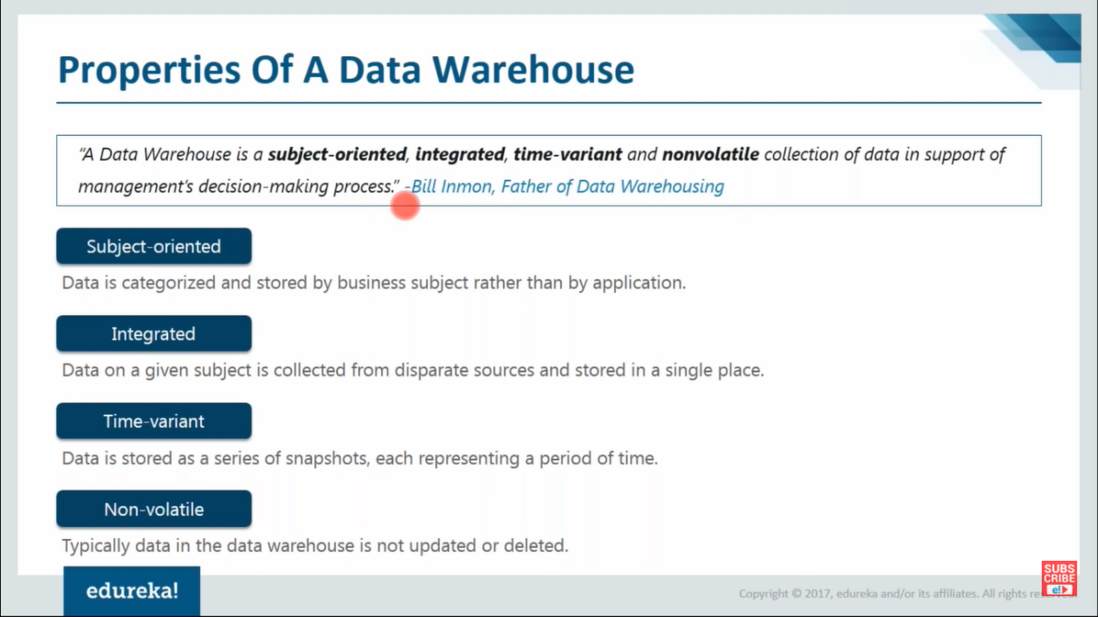

Subject oriented--

Integration--Data collected from multiple places & stored in single place

Time variant--

Non volatile-- Once data inserted into DW it cant be changed(possible but with a complicated procces which is highly recommended not to do).

**Key terminologies related to DWH architecture.**

1. OLTP vs OLAT
2. ETL
3. Data Mart
4. MetaData
5. **OLTP(online transactional processing-DB) VS OLAP(online analytical processing-DW)**

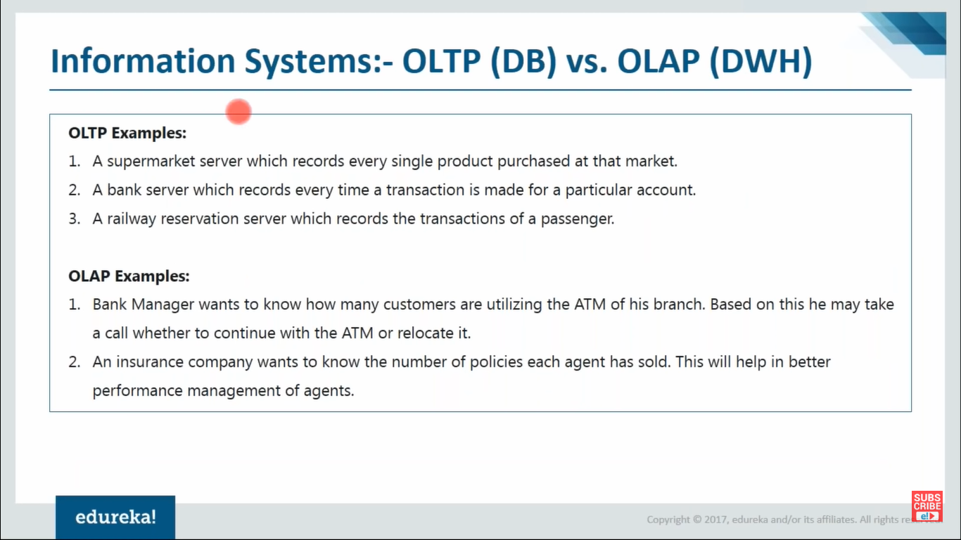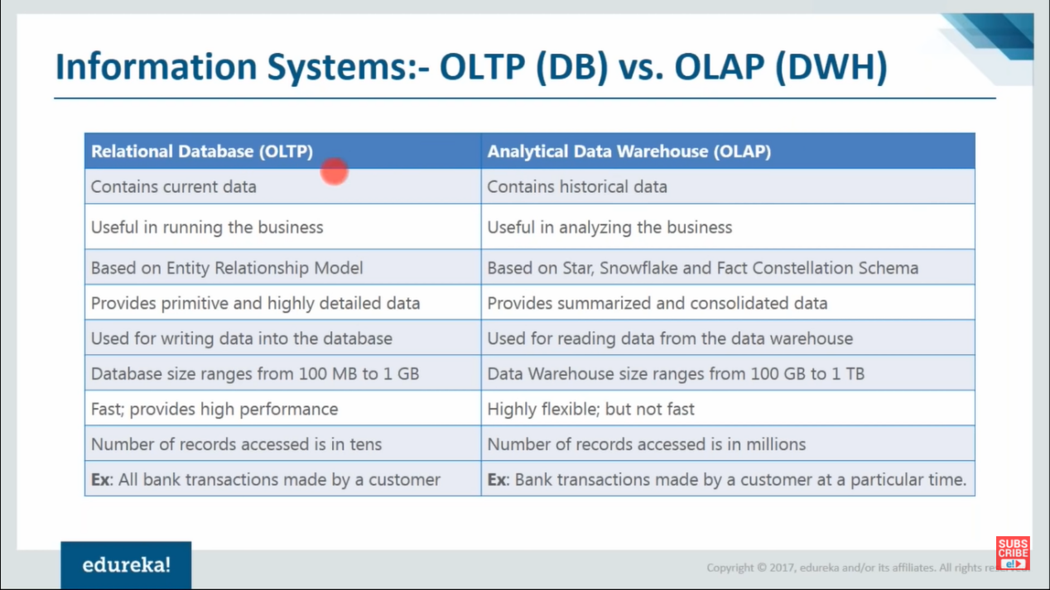

1. **ETL**

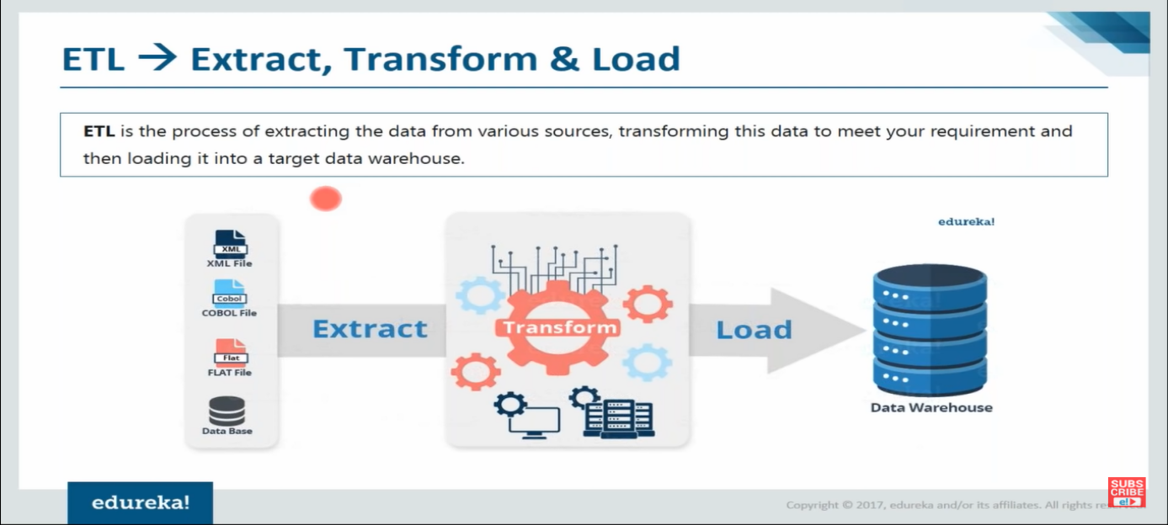

1. **Data mart**

**Used To enable more security & integrity**

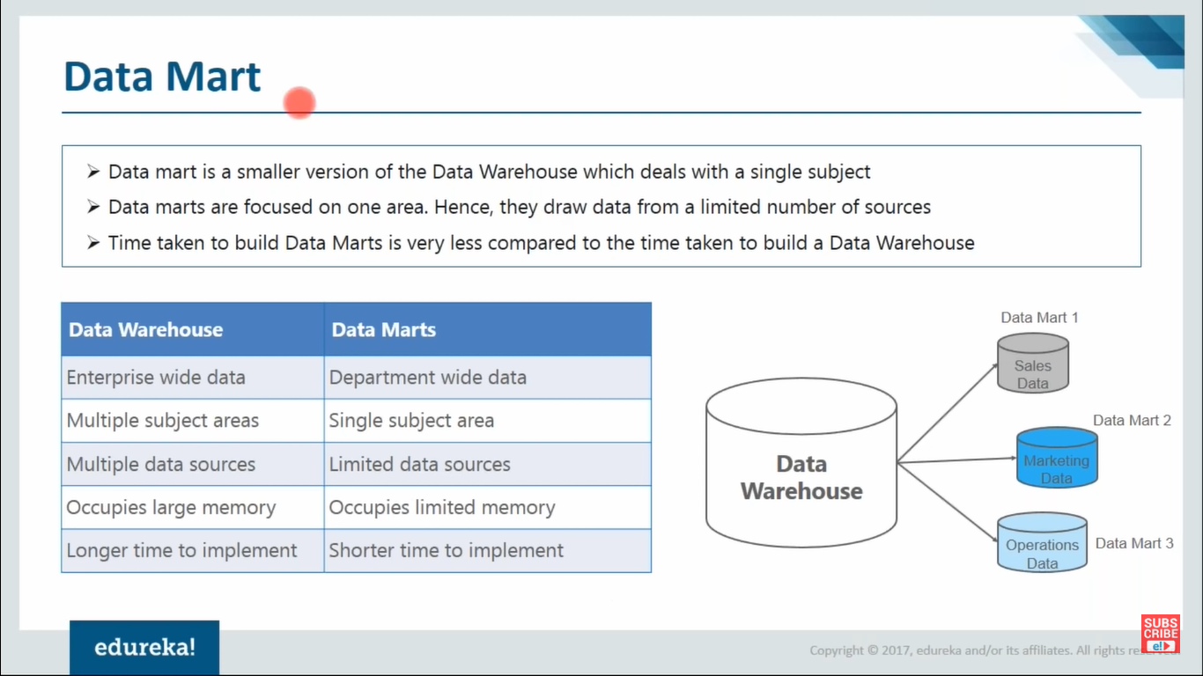

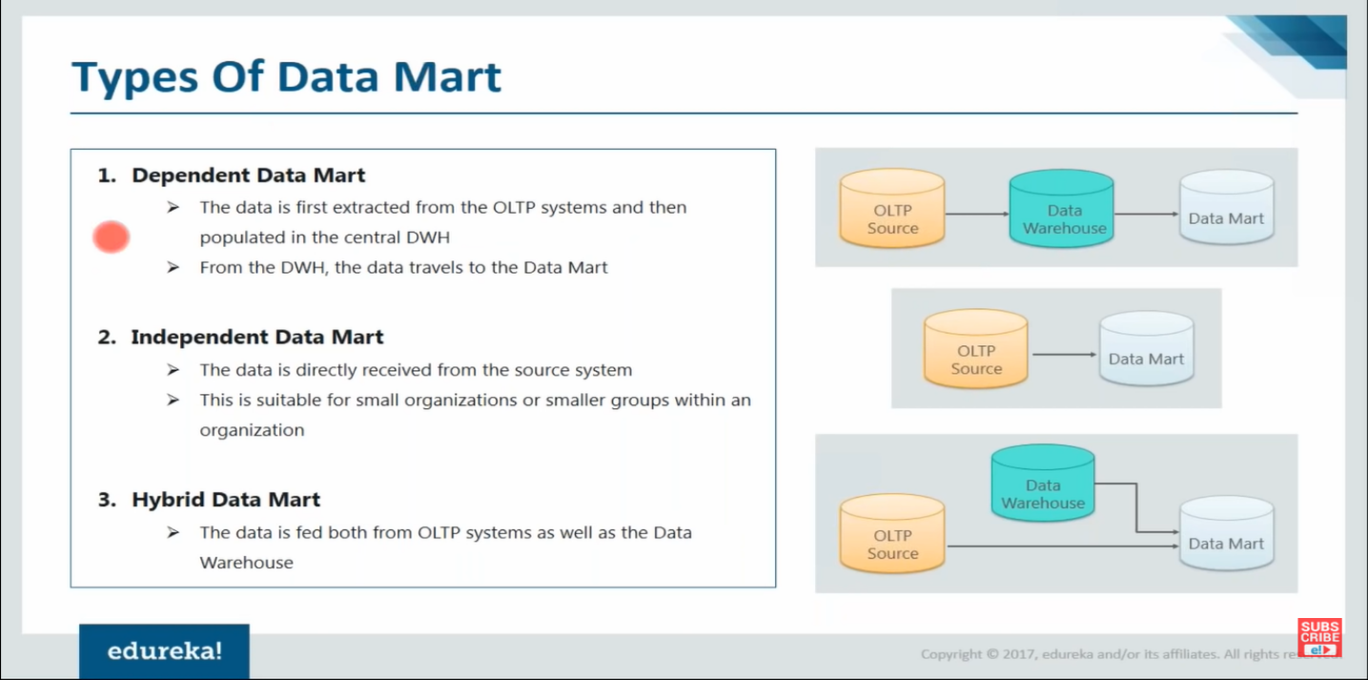

1. **Metadata**

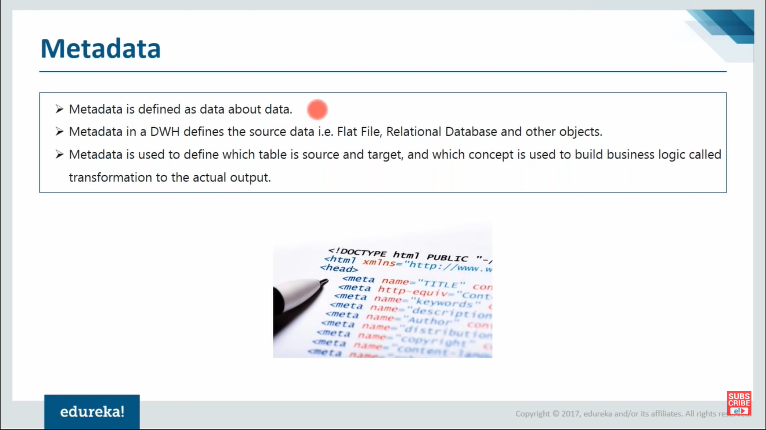

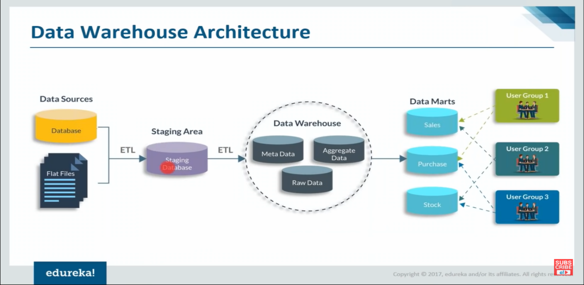

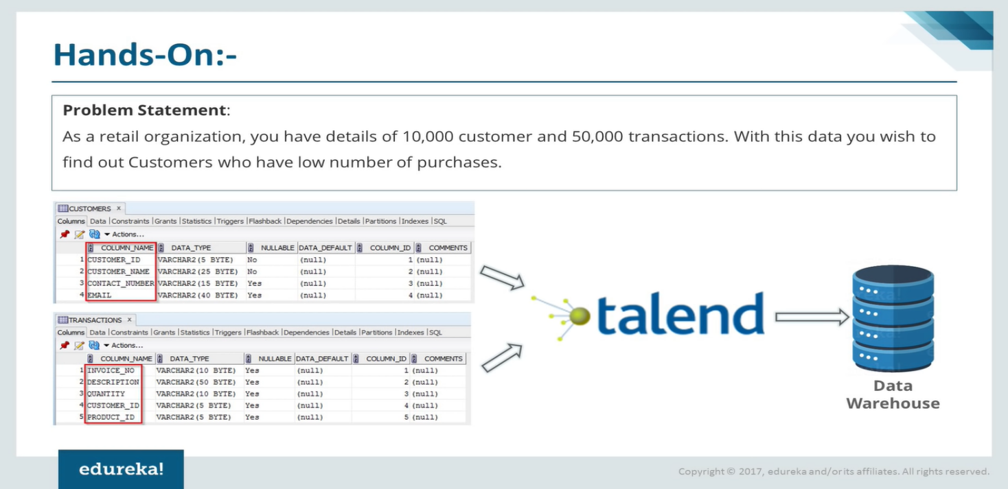

**SimpliLearn**

**DataWarehouse:**  It is central Repository of integrated data

2 Major functions of DW

1. To maintain present & past historical records.
2. To help organization to take effective business decisions with Precise data analysis.

It supports tool of ETL solution, Data mining, Statistical analysis, reporting & OLAP tools

**Key Features of Data Warehouse:**

1. **subject oriented**

Gives answers to diverse questions & is used by all functional areas

1. **Integrated**

**\***Centralized

* Holds entire organization’s data

1. **Non volatile**

*Data Never be removed

* Data always grows

1. **Time varient**

Data collected in DW is identified with particular time period, So this data provides information from historical POV.

**Frequently used terms in DW**

1. Metadata
2. OLAP - It is computer processing which allows users to analyze multi-dimensional data from multiple prospects.

*It supports multi dimensional queries

*Enable users to view the same data in different ways.

*Each aspect of information(attribute) represents different dimension.

1. ETL - movement of data from 1 place to another
2. Drill Across- It allows data analysis across multiple dimensions
3. Drill Up- It allows data analysis upto the parent attribute
4. Drill Down- It allows data analysis down to tha child attribute
5. Drill Through- It allows data analyzing data from an OLAP cube with Relational DB
6. Data mart - It is a subset of DW which is aligned to specific business perspective. Stores data about specific subject in summarized form.

**OLAP vs OLTP**

2 Different types of data analysis techniques

Screenshots

**DW architecture**

**Data Source-** It refers various data sources in multiple formats like RDBS, Excel files etc.

This Data is extracted & put in staging area

**Staging Area -** Here the Data Processing I.e Data cleaning & Data ordering takes place,filtering bad data etc

**WareHouse -** It transforms Transactional data into analytical data using business intelligent logic.

Most time consuming phase

**Data Marts -** Successfully cleaned, Integrated,transformed data is stored in a multi dimensional environment which is available for querying & analysis

**Presentation**- Bi tools are used to convert this data into dashboards which is then used to plan business strategies

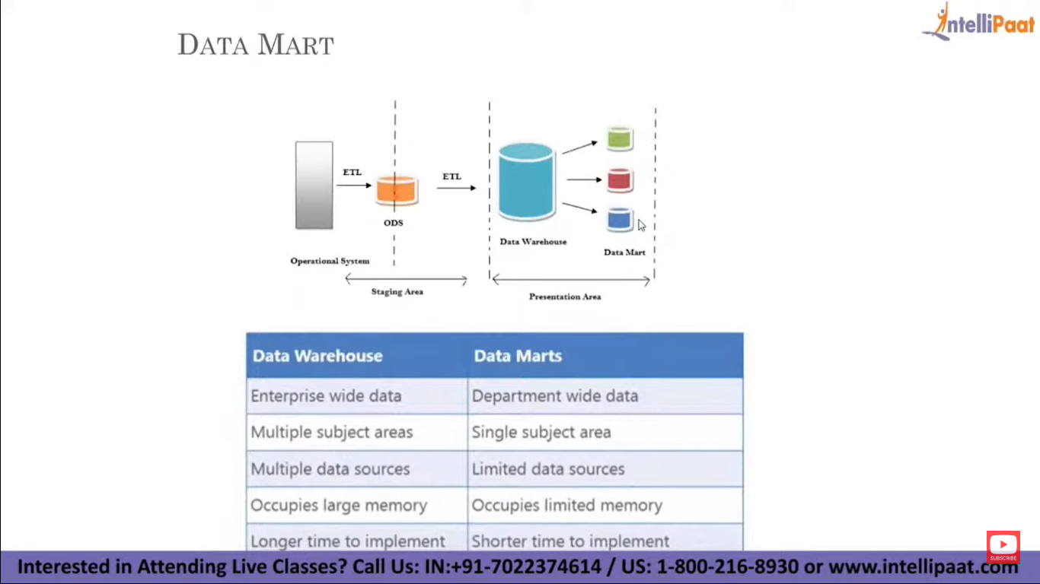

**Datawarehousing tools**

Amazon redshift, Mark Logic, Oracle Data warehouse etc

**Key points**

* **OLTP database -** Database is designed to maintain recent transaction in it because querying large amount of data takes large amount of time as this data slows down the process.(db is designed not to maintain large amount of data).

* **Historical transaction db(data warehouse)** - some parallel databases created to maintain the previous data which the first db deleted (Nothing is deleted from this db).

* OLTP contains latest data, we cant take decision (generate report) based on this data but it can be done on OLAP data & analyze.

* **ODS(operational database) -** It is a replica of OLTP data base(having same tables & schema), It is used to increase the performance, as some of applications(supposed to be connected to OLTP) are connected to this.

ODS & OLTP are in sync I.e any changes,update,insertion done in ODS will be updated in OLTP & vice versa

**Need for ODS**

1. As OLTP has sensitive data, this acts as backup
2. As all customers cant be connected to single db, As it reduces performance.

* From ODS data will be loaded into datawarehouse(Not directly but through staging database).

* **Staging Area/DB** - Every data from ODS table is transformed & loaded into Staging database

In staging area we have constrains(to validate columns/attributes ex: not null constrain for salary column) for tables which doesn’t allows wrong data to get into table & there will be failure which need to be taken care of.

\***DW -** All data of staging area is transformed & stored in DW

Only datawarehouse contains dimension & fact tables.

* **Data mart** - It stores part of data(like only 3 years transaction) of data warehouse which is needed for analysis.

It is then used by BI analysts to create reports.

--------------------------------screenshot----------------------------

**Dimension table(DIMs)** - It contains primary key & master data(Non measurable data/columns)

**Fact tables-** It contains primary keys of DIMs(foreign key to this table) & measurable columns

--------------------------------screenshot----------------------------

**Different types of schema in Data Warehouse-**

1. Star Schema

If Fact table is connected to all the dimension table I.e. the primary keys of all the Dimension table should be present in Fact table

1. Snowflake Schema

If Only few of dimension keys are present in the fact table i.e only few dimension tables connected.

Even if one dimension table is not connected to fact table then it is a snowflake schema.

**4 Types of dimensions(Dims)**

1. **Conform /Reusable Dimension**

If any dimension is reused across multiple projects (ex: Calendar dimension/column, It remains same across all the project) then that DIM is called conform Dimension(DIM)

1. **Junk Dim**

THe data which change/updated regularly like every second, every minute(Ex: Stock market data)

1. **Degenerated Dim**

If any dimension table shares its non measurable data with its Fact(fact table) then that DIM is called degenerated Dim (ex: Pincode is non measurable but can be stored in Fact as it is a number)

1. **Slowly Changing Dim(SCD)**

(1:20:30)

1. **SCD type 1** -> Has latest/current data

If the data present/updated in source table(some row are updated) is also present/updated in target table(I.e target table is also updated with latest data)

* It contains only latest transaction

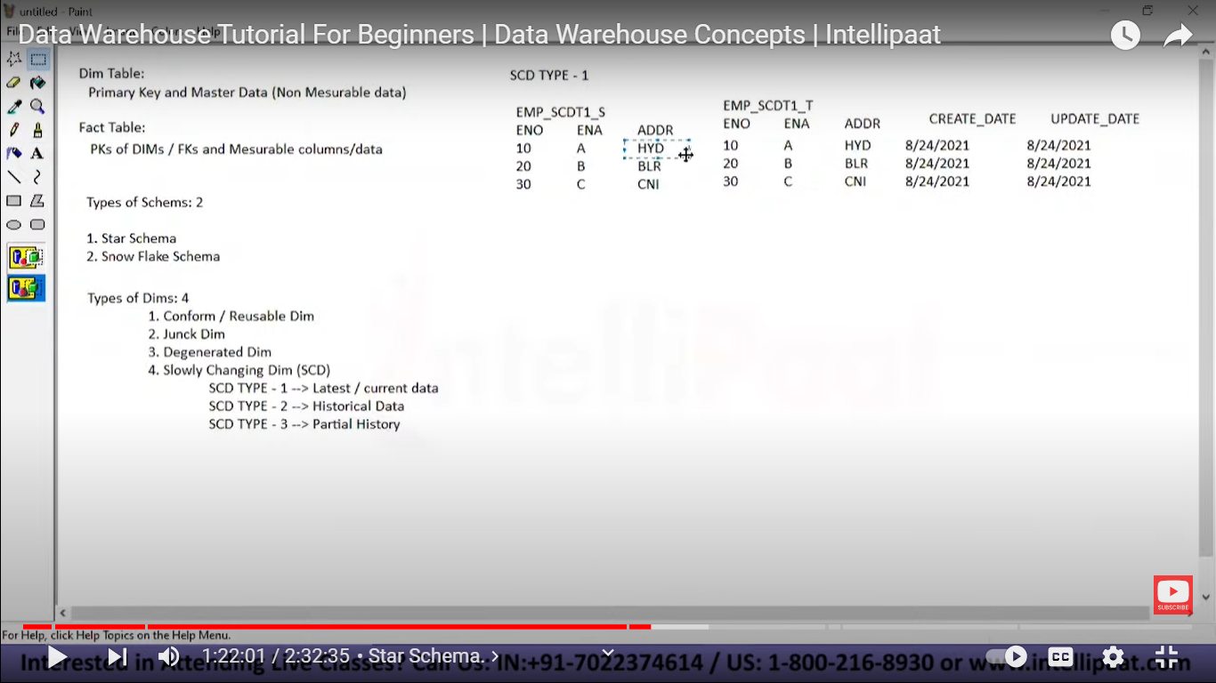

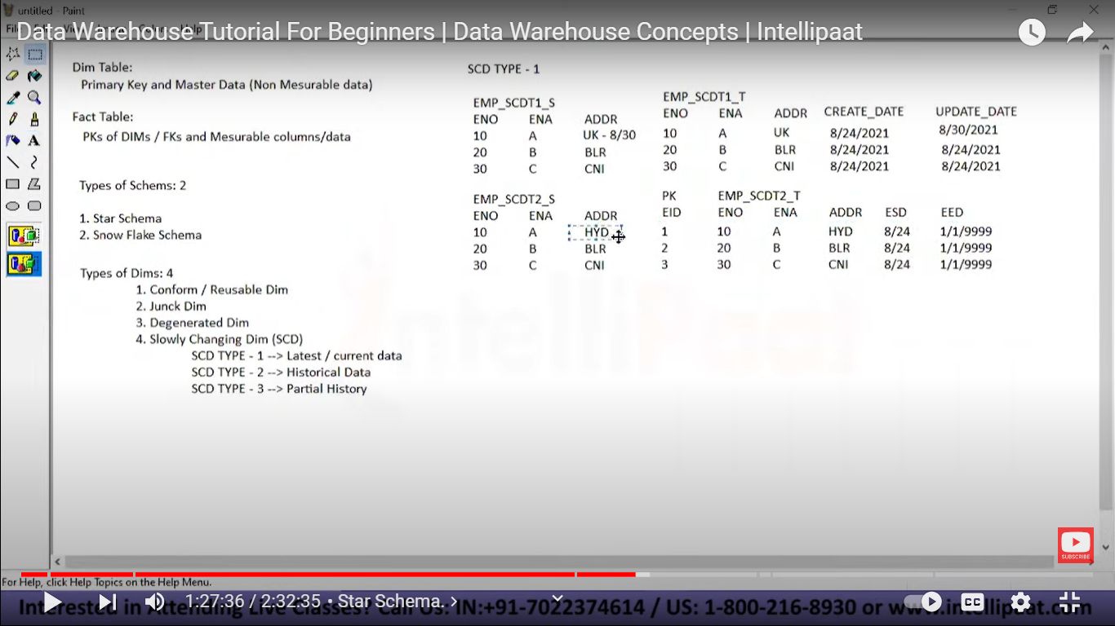

1. **SCD type 2** -> Historical

Here the data present/updated in source table(some row are updated) is not updated in the target table but gets added.

* It contains original,latest, In-between Transaction



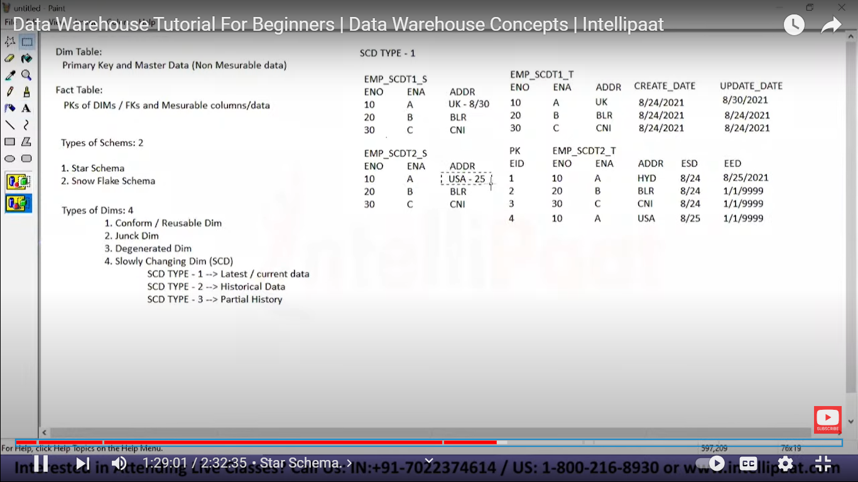

1. **SCD type 3** -> Partial Historical data

Here the data present/updated in source table(some row are updated) is updated in the target table with also maintaining the previous data.

* It contains original& latest Transaction

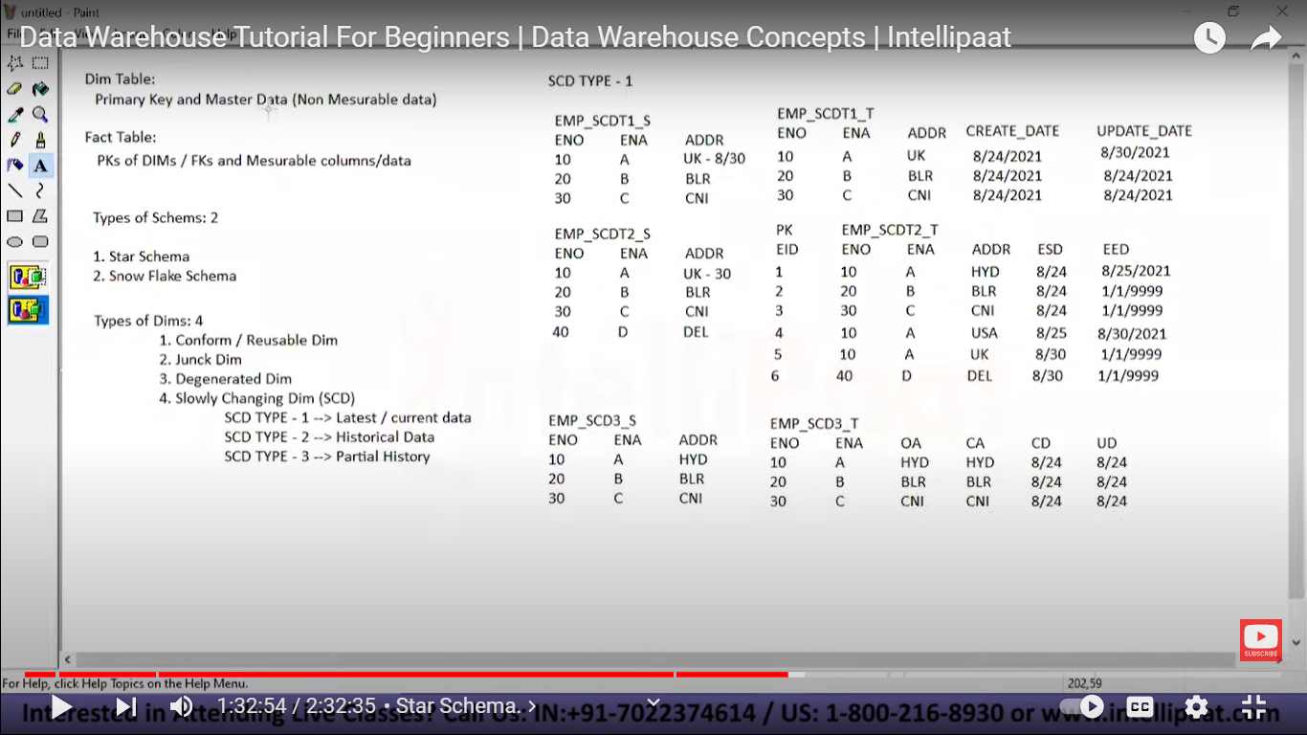

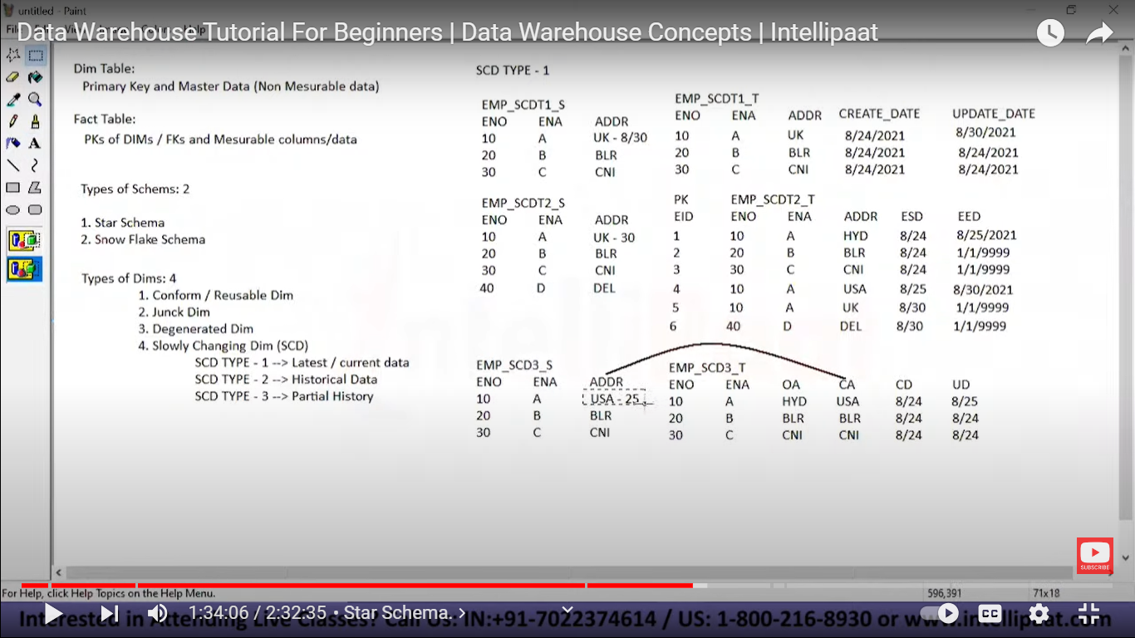

**Types of Facts(Fact table) 4**

1. **Additive fact**

It contains primary keys of DIMs(foreign key to this table) & measurable data

1. **Semi Additive fact**

Contains few of DIM’s PK & measurable data

1. **Non Additive fact**

Contains No DIM’s PK but only measurable data

1. **Fact less Fact**

Contains only DIM’s PK & No measurable data

2 Types of approaches in data warehouse

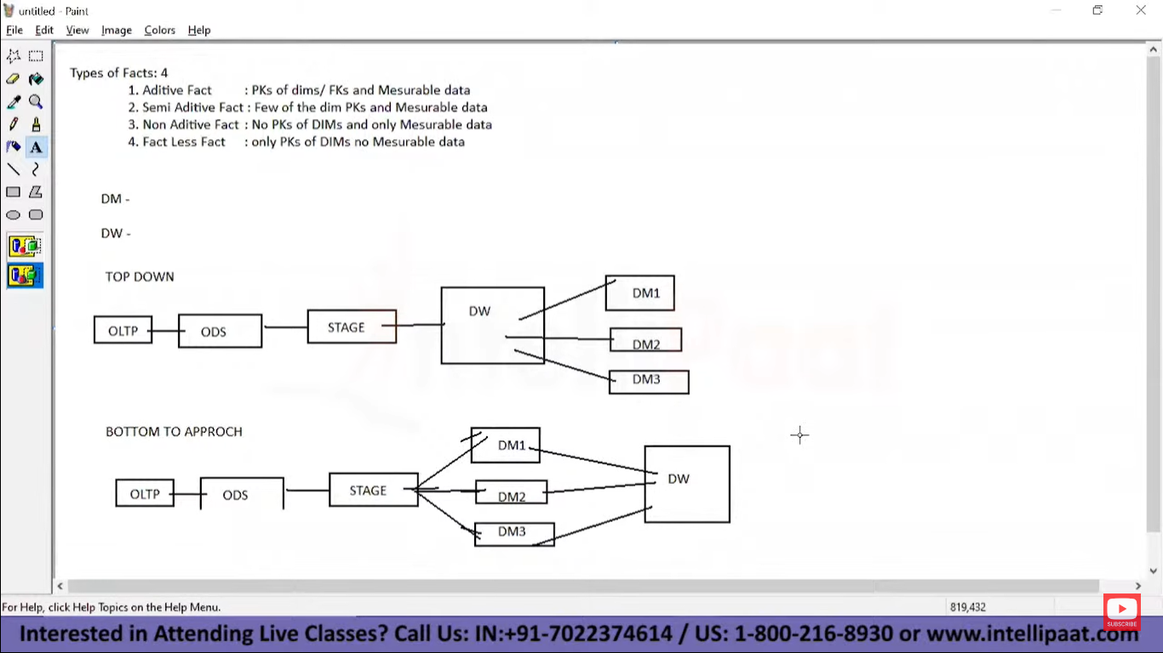

**Data Modeling -**

Data modeling is the process of creating a visual representation of either a whole information system or parts of it to communicate connections between data points and structures.

1. **Conceptual Data Model**

Here we a have a business Concept & according to that a data model is created by including Important entities(columns) required for that concept.

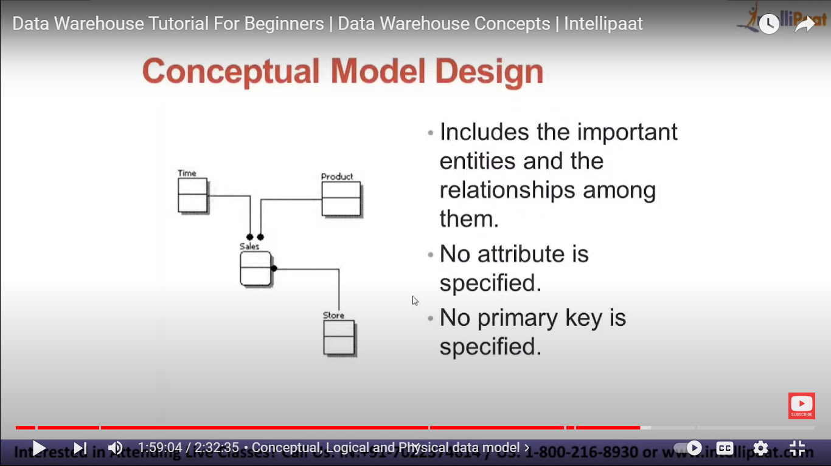

No attribute is specified

No Primary key is specified

* It is highly abstract,No attribute is specified

* easily understood

*easily enhanced

* Only “entities” visible

*abstract relation ship

*No software tools required to define a conceptual data model

1. **Logical Data model**

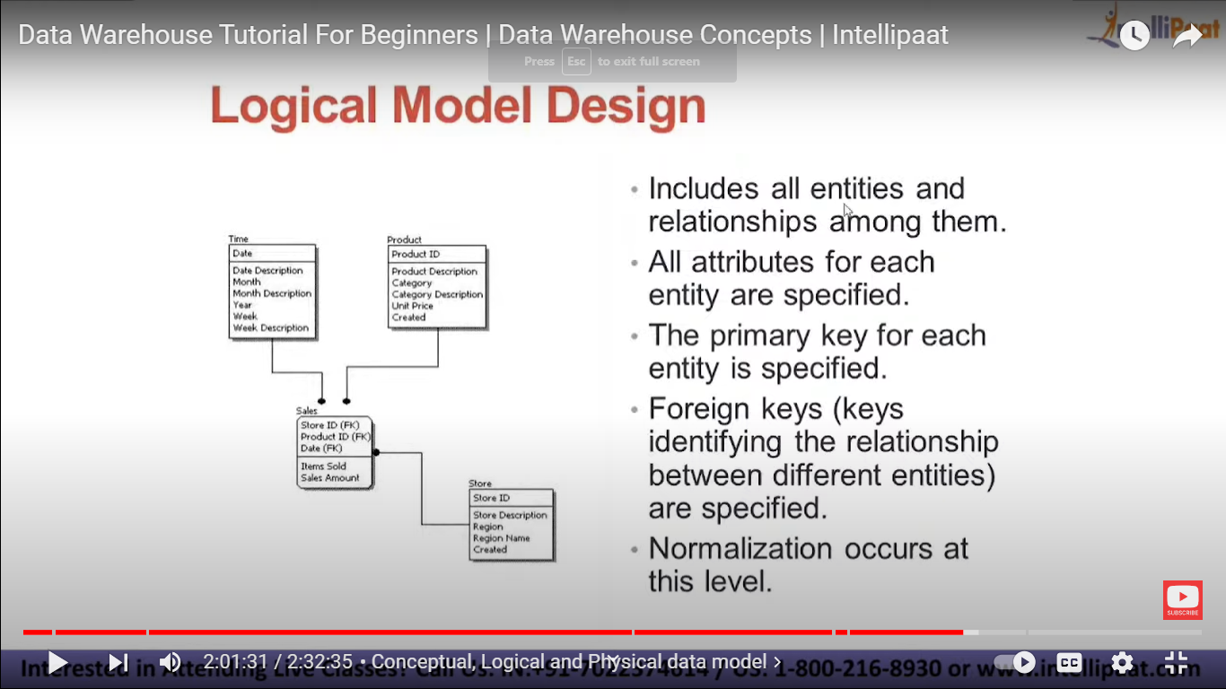

*It includes all entities & relationship

among them

* all attributes for each entity is specified

*The PK for each entity is specified

* FKs are specified

*Normalization occurs at this level

* This gives more details than previous

model

1. **Physical Data Model**

Each table have column attribute,datatype & data length of attribute.

**Cluster Analysis -** [Data Mining - Cluster Analysis - GeeksforGeeks](https://www.geeksforgeeks.org/data-mining-cluster-analysis/)